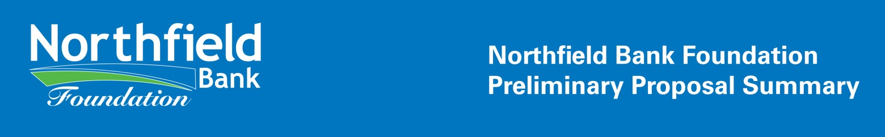

The first step in the Northfield Bank Foundation grant application process is to submit a Preliminary Proposal Summary. The Preliminary Proposal Summary, a shortened version of our Full Grant Application Package, will help us determine which proposals best fit our funding priorities.

Please contact the Foundation at (718) 303-4265 prior to submitting any requests.

Based on this Preliminary Proposal Summary, organizations may be invited to submit a formal Grant Application Package.

Date of application: ____________________

ORGANIZATION INFORMATION
_______________________________________________________________________________________________

ORGANIZATION MUST BE AN IRS DESIGNATED 501(C)(3) IN GOOD STANDING.

Organization: _______________________________________________

Address of organization: _______________________________________________

_______________________________________________

Telephone/Fax: _______________________________________________

Email: _______________________________________________

Web Site: _______________________________________________

Executive Director: _______________________________________________

Contact Person/Title: _______________________________________________

Federal Tax ID #: _______________________________________________

_____________________________________________________________________________________________

Northfield Bank Foundation • 1731 Victory Boulevard • Staten Island, NY 10314 • (718) 303-4265 • (732) 587-2225 • northfieldbankfoundation.org
Geographic Area Served: _______________________________________________

Brief History of Organization: _______________________________________________

_______________________________________________

_______________________________________________

Organization’s Mission Statement: _______________________________________________

FINANCIAL INFORMATION
_______________________________________________________________________________________________

Organizational Annual Operating Budget ($): _______________________________________________

Organizational Net Assets At
End of Last Fiscal Year ($): _______________________________________________

Organization’s Revenue & Expenses for each of the last 3 years as stated on Form 990:

2023 Revenue _________________ 2023 Expenses _________________

2022 Revenue _________________ 2022 Expenses _________________

2021 Revenue _________________ 2021 Expenses _________________

Attach a listing of your Board of Directors with their affiliations. Also list your Board of Directors annual giving to your organization.

No
Yes
Does your organization have: Conflict of Interest Policy
Yes
No
Audit or Finance Committee
Whistle Blower Policy
Yes
No

List the 3 highest Paid Employees and their Titles:

_______________________ ______________________ ______________________

_____________________________________________________________________________________________

Northfield Bank Foundation • 1731 Victory Boulevard • Staten Island, NY 10314 • (718) 303-4265 • (732) 587-2225 • northfieldbankfoundation.org
List the 3 most significant Donors and Totals for each of the last 3 years:

2023 ________________________ 2022 ________________________

2021 ________________________

PROGRAM INFORMATION
_______________________________________________________________________________________________
Name of Program: _______________________________________________

Description of Program: _______________________________________________

_______________________________________________

_______________________________________________

_______________________________________________

Primary Need Addressed by Program: _______________________________________________
_______________________________________________

_______________________________________________

Project Start Date: _______________________________________________

Funding Requested ($): _______________________________________________

Total Project Budget ($): _______________________________________________
(Attach a detailed budget for this project)

Other sources of Committed Funding
And funding amounts: _______________________________________________

_______________________________________________

Please submit a copy of your 501(c)(3) form along with this application.
Submit via regular mail to: Northfield Bank Foundation, 1731 Victory Boulevard, Staten Island, NY 10314

_____________________________________________________________________________________________

Northfield Bank Foundation • 1731 Victory Boulevard • Staten Island, NY 10314 • (718) 303-4265 • (732) 587-2225 • northfieldbankfoundation.org

